**Institute of Computer Technology**

**B. Tech Computer Science and Engineering**

**Sub: Algorithm Analysis and Design**

**Practical 1**

**(1)** There are 2 chefs, namely chef 1 and chef 2 in the MasterChef competition. The judge is going to judge on the basis of 3 categories: presentation, taste and hygiene to prepare the dishes. The marking is scaling from 1 to 100. The rating for chef 1 challenge is the triplet a = (a[0], a[1], a[2]), and the rating for Chef 2 challenge is the triplet b = (b[0], b[1], b[2]), where 0 index is presentation, 1 index is taste and 2 index is hygiene.

The task is to find their comparison points by comparing a[0] with b[0], a[1] with b[1], and a[2] with b[2].

* If a[i] > b[i], then Chef 1 is awarded 1 point.
* If a[i] < b[i], then Chef 2 is awarded 1 point.
* If a[i] = b[i], then neither person receives a point.

Comparison points are the total points a person earned.

Given a and b, determine their respective comparison points.

Design the algorithm for the same and implement using the programming language of your choice. Make comparative analysis for various use cases & input size.

**Sample Input 1**

27 48 70

89 26 7

**Sample Output 1**

2 1

**Explanation 1**

Comparing the 0th elements, 27<89 so Chef 2 receives a point.

Comparing the 1st and 2nd elements, 48>26 and 70>7 so Chef 1 receives two points.

The return array is [2,1].

Code:

App.py:

from flask import Flask, render_template, request

app = Flask(__name__)

def compare_chefs(chef1_scores, chef2_scores):

    points_for_chef1 = 0

    points_for_chef2 = 0

    for i in range(3):

        if chef1_scores[i] > chef2_scores[i]:

            points_for_chef1 += 1

        elif chef1_scores[i] < chef2_scores[i]:

            points_for_chef2 += 1

    return [points_for_chef1, points_for_chef2]

@app.route('/')

def index():

    return render_template('index.html')

*# Route for Task 1 page*

@app.route('/task1')

def task1():

    return render_template('task1.html')

*# Route for Task 2 page*

@app.route('/task2')

def task2():

    return render_template('task2.html')

@app.route('/compare', methods=['POST'])

def compare():

    chef1_scores = [

        int(request.form['chef1_presentation']),

        int(request.form['chef1_taste']),

        int(request.form['chef1_hygiene'])

    ]

    chef2_scores = [

        int(request.form['chef2_presentation']),

        int(request.form['chef2_taste']),

        int(request.form['chef2_hygiene'])

    ]

    result = compare_chefs(chef1_scores, chef2_scores)

    return render_template('result.html', result=result)

*#  Task 2*

def find_closest_to_zero_pair(arr):

    arr.sort()

    left=0

    right = len(arr) - 1

    min_sum = float('inf')

    closest_pair = None

    while left < right:

        current_sum = arr[left] + arr[right]

        if abs(current_sum) < abs(min_sum):

            min_sum = current_sum

            closest_pair = (arr[left], arr[right])

        if current_sum < 0:

            left += 1

        else:

            right -= 1

            return closest_pair\

@app.route('/find_pair', methods=['POST'])

def find_pair():

    input_array = request.form['input_array']

    arr = list(map(int, input_array.split(',')))

    closest_pair = find_closest_to_zero_pair(arr)

    return render_template('result1.html', input_array=input_array,

closest_pair=closest_pair)

if __name__ == '__main__':

    app.run(debug=True)

Index.html:

<!DOCTYPE html>

<html lang="en">

<head>

    <meta charset="UTF-8">

    <meta name="viewport" content="width=device-width, initial-scale=1.0">

    <title>AAD Practical</title>

    <link rel="stylesheet" href="../static/style.css">

</head>

<body>

  <div class="all">

    <h1>Practical - 1 </h1>

    <div class="btn">

        <a href="{{ url_for('task1')}}">

    <button>

      <span class="button_top"> Task_1

      </span>

    </button></a>

    <a href="{{ url_for('task2')}}">

      <button>

        <span class="button_top"> Task_2

        </span>

      </button></a>

    </div>

</div>

</body>

</html>

Task1.html:

<!DOCTYPE html>

<html lang="en">

<head>

    <meta charset="UTF-8">

    <meta name="viewport" content="width=device-width, initial-scale=1.0">

    <title>Chef Comparison</title>

    <link rel="stylesheet" href="../static/task1.css">

</head>

<body>

    <div class="container">

        <h1>Chef Comparison</h1>

        <form action="/compare" method="post">

            <div class="chef-scores" id="chef1">

                <h2>Enter the scores for Chef 1</h2>

                <label for="chef1-presentation">Presentation:</label>

                <input type="number" name="chef1_presentation" min="0" max="100"

required>

                <label for="chef1-taste">Taste:</label>

                <input type="number" name="chef1_taste" min="0" max="100"

required>

                <label for="chef1-hygiene">Hygiene:</label>

                <input type="number" name="chef1_hygiene" min="0" max="100"

required>

            </div>

            <div class="chef-scores" id="chef2">

                <h2>Enter the scores for Chef 2</h2>

                <label for="chef2-presentation">Presentation:</label>

                <input type="number" name="chef2_presentation" min="0" max="100"

required>

                <label for="chef2-taste">Taste:</label>

                <input type="number" name="chef2_taste" min="0" max="100"

required>

                <label for="chef2-hygiene">Hygiene:</label>

                <input type="number" name="chef2_hygiene" min="0" max="100"

required>

            </div>

            <button type="submit">Compare</button>

        </form>

    </div>

</body>

</html>

Result.html:

<!DOCTYPE html>

<html lang="en">

<head>

    <meta charset="UTF-8">

    <meta name="viewport" content="width=device-width, initial-scale=1.0">

    <title>Comparison Results</title>

    <link rel="stylesheet" href="../static/task1.css">

</head>

<body>

    <div class="container">

        <h1>Comparison Results</h1>

<p>Chef 1: {{ result[0] }} points</p>

<p>Chef 2: {{ result[1] }} points</p>

<a href="/"><button type="submit">Back to home</button> </a>

</div>

</body>

</html>

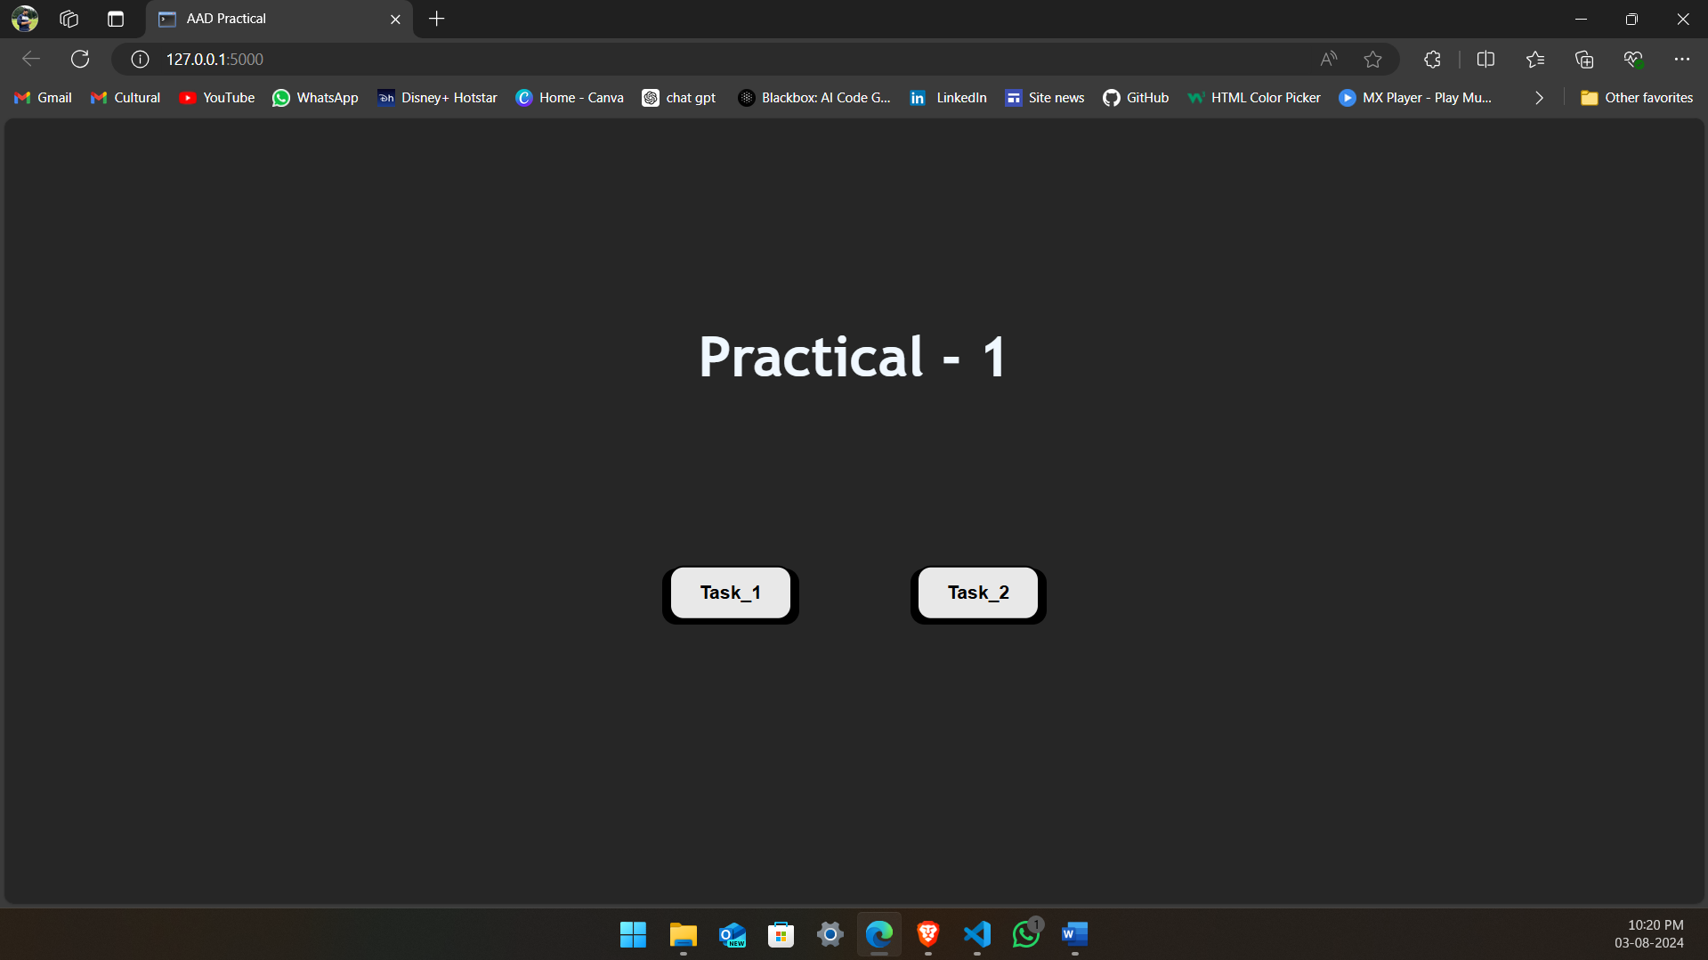

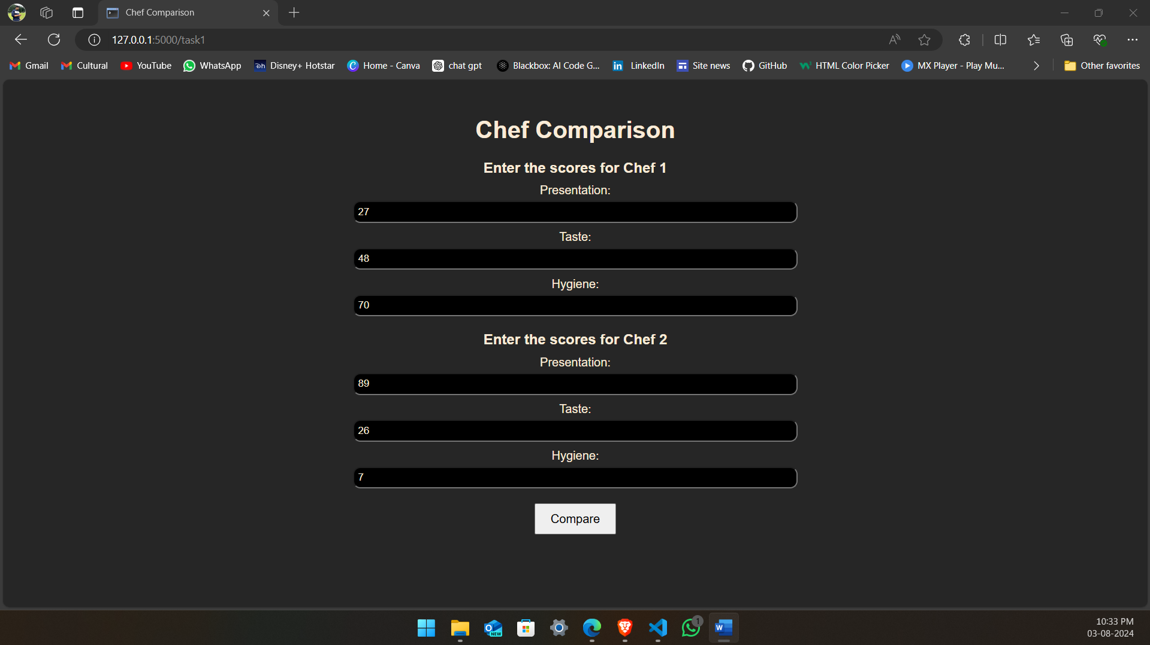

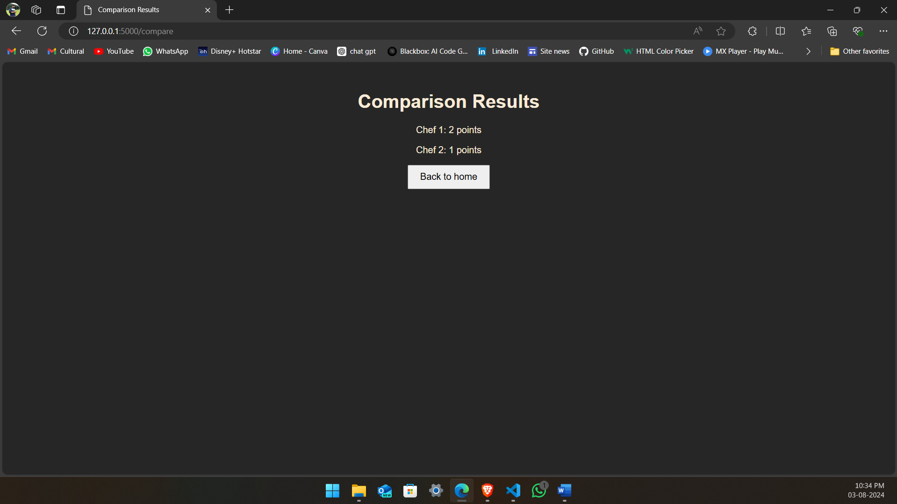

**(2)** Let us suppose that you are having an array containing both positive and negative numbers. Given the numbers you are supposed to find 2 such elements such that the sum of those numbers is closest to zero.

**Code:**

**App.py:**

**Here I have combined both the python code into one for website here is the second one , entire code is available in first screen shot of App.py**

***#  Task 2***

**def find_closest_to_zero_pair(arr):**

**arr.sort()**

**left=0**

**right = len(arr) - 1**

**min_sum = float('inf')**

**closest_pair = None**

**while left < right:**

**current_sum = arr[left] + arr[right]**

**if abs(current_sum) < abs(min_sum):**

**min_sum = current_sum**

**closest_pair = (arr[left], arr[right])**

**if current_sum < 0:**

**left += 1**

**else:**

**right -= 1**

**return closest_pair\**

**@app.route('/find_pair', methods=['POST'])**

**def find_pair():**

**input_array = request.form['input_array']**

**arr = list(map(int, input_array.split(',')))**

**closest_pair = find_closest_to_zero_pair(arr)**

**return render_template('result1.html', input_array=input_array,**

**closest_pair=closest_pair)**

**if __name__ == '__main__':**

**app.run(debug=True)**

Result1.html:

<!DOCTYPE html>

<html lang="en">

<head>

    <meta charset="UTF-8">

    <meta name="viewport" content="width=device-width, initial-scale=1.0">

    <title>Closest Pair Result</title>

    <link rel="stylesheet" href="../static/task1.css">

</head>

<body>

    <div class="container">

        <h1>Result</h1>

        <p>Input Array: {{ input_array }}</p>

        <p>Closest Pair: {{ closest_pair }}</p>

        <a href="/"><button type="submit">Back to home</button> </a>

    </div>

</body>

</html>

Task2.html:

<!DOCTYPE html>

<html lang="en">

<head>

    <meta charset="UTF-8">

    <meta name="viewport" content="width=device-width, initial-scale=1.0">

    <title>Find Closest Pair to Zero</title>

    <link rel="stylesheet" href="../static/task1.css">

</head>

<body>

    <div class="container">

        <h1>Find the Pair with Sum Closest to Zero</h1>

        <form action="/find_pair" method="post">

            <label for="input_array">Enter array elements separated by commas:</label>

            <input type="text" id="input_array" name="input_array" required>

            <button type="submit">Find Pair</button>

        </form>

    </div>

</body>

</html>

Output:

Sample Input 2

15, 5, -20, 30, 25

Sample Output 2

15, -20 & -20, 25

Explanation 2

In all the comparison, the sum of 15,-20 & -20, 25 is smallest amount among all other comparison.

